Sign Rulers
Thursday, March 26, 2020
1:21 AM

WHAT ARE RULERSHIPS IN TRADITIONAL ASTROLOGY?
Rulerships are a simple classification of how different planets and signs of the Zodiac are related and the level to which they can be combined with success. Rulerships tell us how strong the placement of certain planets are in certain signs; to this end, many people use the analogy of ‘being at home’; in astrological terms this is what we call ‘planet dignity’.
In certain zodiac signs, the planet will be what we call ‘dignified’, that is, it will feel very much at home and comfortable in that particular zodiac sign. It’s like walking around a city you already know, with a fully powered phone that has full connection to data. You already know your way around, and even if you got lost for a second, you’d be able to hop online and google your way through it. When a planet is dignified, also known as ‘domiciled’, you feel that you have the knowledge, comfort and tools required to get the job done.
Analyzing rulerships largely deal with understanding if the planet is at home, and therefore dignified, or if it is not feeling comfy at all, and possibly weakened, which is known as being in ‘detriment’ or ‘fall’. And still further, there are places where particular planets LOVE to be, a type of planetary paradise which is called ‘exaltation’.
TO QUICKLY RE-CAP BEFORE WE CONTINUE:
PLANETS IN A CERTAIN SIGN CAN EITHER BE CONSIDERED AS IN A STATE OF ‘DOMICILE’ (HOMEY COMFORT), ‘DETRIMENT’ (LIKE SLEEPING AT A NEIGHBOR’S OR DISTANT RELATIVE’S HOUSE – NOT THE BEST OR THAT COMFORTABLE), ‘FALL’ (LIKE SLEEPING IN A SHELTER – NO EXPLANATION REQUIRED) OR ‘EXALTATION’ (FIVE-STAR LUXURY HOTEL).
Many of you may be making the next natural connection which is – what the hell? Does that mean if I have Venus in Aries (which is in ‘detriment’) I’m always going to have difficult relationships?
Well, the truth is…maybe yes, maybe no. It all depends on how willing and able you are to work with that planet/sign combination to bring out the best of it, while not falling slave to the worst of its expression.
Awareness is everything, and in the words of Audre Lord, ‘we pay a lot for awareness’: we may have to hit the wall with this planet/zodiac combination over and over before our awareness comes to the level where we can transmute that energy into something higher.
THE ESSENTIAL PLANET DIGNITIES CHART
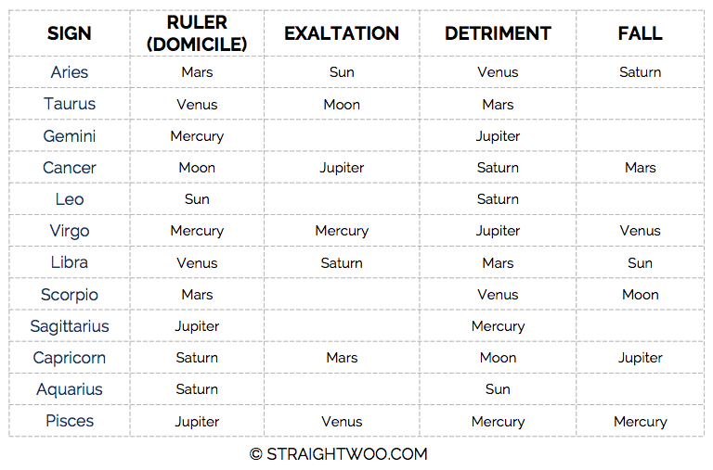

Note that this is a pared-down version of Ptolemy’s Essential Chart of Planet Dignities. If you want to see more about that, you should check out this post instead.
AN EXAMPLE OF HOW DIGNITIES WORK
Using Venus in Aries as our first example: a calm, nurturing, gentle planet that wants to connect and enjoy the comforts of life (Venus) finds themselves in the home of a brave, daring, bold, combative, impulsive friend (Aries).
On the high side, a Venus in Aries expression is ALWAYS making connections. They’re not afraid to walk straight up to someone they don’t know and start up a conversation. They’re continually out making the rounds, drumming up enthusiasm for some wild night out on the town, project or scheme, and the sheer physicality of their way of life means they’ll vent out a lot of stress and pressure through risky and/or physical challenges.
On the low side, Venus in Aries may spend too many nights wondering why their new paramour didn’t call back or what happened to that great connection they made the another night outside of the post office. They’ll flop deeply into a depression, before it completely slips from their mind and they’re back out on the prowl, enacting the same pattern again and again. They might marry, date (or do the horizontal tango – ai-yi-yi) with someone a bit too quickly, before they know if the person they’re exchanging energies with is truly worth their time. And when they’re really out of balance, the Aries individual’s love might burn up too quick or be suffocated in the flames of passion.*
See how this works? It’s not necessarily a disaster – you’ve just got to be a bit Charles in Charge, put on your big girl panties and take your higher self out for an interventionist coffee date, à la Linda Richman.
HOW CAN I USE RULERSHIPS?
There are a number of ways you can start using planetary rulerships, even you aren’t a professional astrologer or dedicated student of astrology. If you have an interest in how astrology intersects in your life, rulerships are one of the first and most useful tools you can use to gain more insight into your own chart.
Here are some easy, great ways to start using rulerships:
- Understanding your planetary rulers. Example: if your Sun is in Aries, the ruler of your Sun sign according to our chart is MARS. Therefore, you’ll want to pay more attention if Mars moves retrograde, which happens every 2 eyars. If your Moon was in Pisces, the ruler is JUPITER. You’ll want to track and follow Jupiter transits more closely, knowing that they’ll relate to your Moon. This is most relevant to the Sun, Moon and Ascendant of your chart, as these are generally accepted as being the 3 most powerful/important places in our charts.
- Moon Cycles. Each lunation (New or Full Moon) is ruled by a planet. EX: if we had a Full Moon in Sagittarius, according to our chart JUPITER is the ruler of Sagittarius. The Full Moon itself may occur elsewhere in your chart, but it can also impact the house where your natal Jupiter resides.
- Investigating the Houses of your Natal Chart. Each part of your natal chart is ruled by a different sign, and this gives interesting insight into each house. If your 7th House of Marriage/Partners and ‘Open Enemies’ (the ancients knew their stuff, clearly) is ruled by Aries, which is ruled by Mars, you’ll know upfront a few things: your relationships will be daring, risky, independent, free (Aries); when ruled by Mars, you might have intense, passionate partners, or partners that have a tendency to fight, argue, etc. Note that this is a VERY basic way of using this information and I urge you not to go too far down the garden path with this, but, it’s very helpful and interesting, all the same.

From <http://straightwoo.com/2016/05/06/how-to-use-rulerships-astrology/>

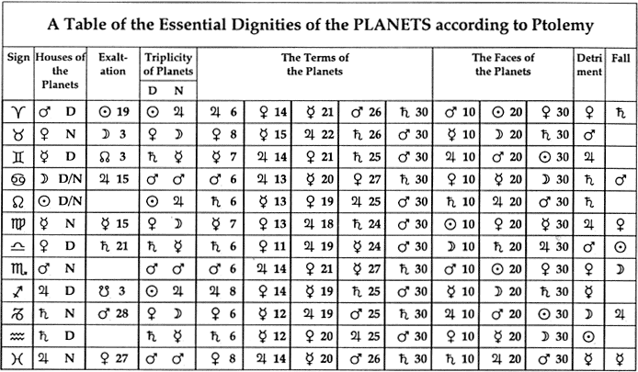

rulerships, dignities, and debilities of the planets
Each planet rules one or more signs. Planets are also classified according to their essential dignities, or strengths. In total, five states of a planet are possible: rulership, detriment, exaltation, fall, and peregrine. In some signs, a planet is able to project itself without hindrance, since it functions in a field harmonious to its own nature. This is called rulership. When the planet is in the sign it rules, it is said to be dignified because it is powerful in its own sign, and can thus express itself freely and totally. Exaltation denotes a sign in which a planet is especially strong. When a planet is in a sign that is an opposing sign to its rulership or exaltation it is said to be debilitated, because the planet is at its weakest due to its hindered expression. Planets in opposite signs to the signs which they rule are in their detriment, and signs in their fall are the signs that are opposite its exaltation. The fifth state is referred to as peregrine, meaning that a planet is in none of the previous four states. Here is the breakdown of the rulerships, dignities, and debilities of the signs and planets.
the sun rules leo, is exalted in aries, in detriment in aquarius, and in its fall in libra
The Sun rules the sign of Leo, and is said to be exalted, or especially strong, in the sign of Aries. Its themes of identity and self-expression are a more challenging fit for the signs of Aquarius (detriment), and Libra (fall) which feels most itself in a group, instead of standing on their own.
the moon rules cancer, is exalted in taurus, in detriment in capricorn, and in its fall in scorpio
The Moon is symbolically connected to the compassionate, spiritually sensitive, emotionally deep sign of Cancer, and informs that powerful sign’s domesticity and protective instincts. The Moon is exalted, or especially strong, in the sign of Taurus, which lends stability to the Moon’s fluctuations and moods. It’s in its detriment in Capricorn, a sign whose worldliness is at odds with the Moon’s domestic nature. And the Moon is in its fall in Scorpio, where it can symbolize suspicion and mistrust.
mercury rules gemini and virgo, is exalted in aquarius, in detriment in sagittarius and pisces, and in its fall in leo
Mercury is most comfortable in the signs of Gemini and Virgo (which rules both signs), and Aquarius (where it’s exalted). Mercury has a more difficult job expressing itself in Sagittarius and Pisces (detriment), which prefer to focus on the big picture rather than the details and trivia that delight Mercury. Its fall is in the sign of Leo, since Mercury’s perceptions tend to be overly subjective and melodramatic, causing the press agent to believe their own hype.
venus rules libra and taurus, is exalted in pisces, in detriment in aries and scorpio, and in its fall in virgo
Venus is happiest in the signs of its rulership, Taurus and Libra, where it feels prosperous and beautiful, and loving Pisces, the sign of her exaltation, a sign where companionship and love is championed. Venus has a harder time expressing beauty and harmony in the tough-edged and militaristic signs of Scorpio and Aries (detriment) and in analytical and hardworking Virgo (fall).
mars rules aries, is exalted in capricorn, in detriment in libra, and in its fall in cancer
Mars rules the sign of Aries, and along with Pluto is the co-ruler of Scorpio. Mars is exalted, or especially strong, in the sign of Capricorn, which provides discipline, focus, and structure to Mars’ raw energy. Mars’ themes of individualism and open aggression are a difficult fit for the polite, partnership-oriented sign of Libra (detriment); and Cancer (fall), which values collectivism and prefers an indirect approach to settling disagreements.
jupiter rules sagittarius, is exalted in cancer, in detriment in gemini, and in its fall in capricorn
Jupiter rules Sagittarius and is exalted, or especially strong, in the sign of Cancer; that sign’s domestic, family-oriented symbolism provides much-needed roots and emotional ballast for Jupiter. Jupiter’s themes of optimism, exploration, and big-picture thinking are not an easy fit for Gemini (detriment), a sign that is too rational to be optimistic and prefers to observe and describe the present rather than envision the future; or for serious, conservative, pragmatic Capricorn (sign of its fall).
saturn rules capricorn, is exalted in libra, in detriment in cancer, and in its fall in aries
Saturn rules the sign of Capricorn. It’s exalted, or especially strong, in the sign of Libra, which offers a keen appreciation for how our decisions and ambitions affect others. Saturn’s hard-edged themes of patiently overcoming hardship, living by the rules, and pursuing worldly ambition are at odds with the nurturing, sentimental, security-loving, domestic world of Cancer (the sign of its detriment), and with the impatience and independence of Aries (the sign of its fall).
uranus rules aquarius, is exalted in scorpio, in detriment in leo, and in its fall in taurus
Uranus is symbolically connected to the unconventional, even revolutionary, sign of Aquarius. Uranus is exalted, or especially strong, in the sign of Scorpio, a sign of transformation that lends a sense of larger purpose to Uranus’ radical changes. It’s in its detriment in Leo, a sign whose emphasis on individual creativity is at odds with Uranus, which represents the principle of egalitarianism. And Uranus is in its fall in Taurus, a sign that values stability and security and doesn’t welcome the kind of disruptive change symbolized by Uranus.
neptune rules pisces, is exalted in cancer, in detriment in virgo, and in its fall in capricorn
Neptune is symbolically connected to the mystical sign of Pisces. Neptune is exalted, or especially strong, in the sign of Cancer, a sign of emotional sensitivity that lends itself extremely well to Neptune’s sense of illusion, creativity, and artistry. Its sign of detriment is Virgo, whose practical, discriminating, and analytical nature makes an uncomfortable home for Neptune’s unconditional love, intuition, and faith. It’s in its fall in Capricorn, a sign whose ambition, realism, need for power, and roots in the material world place it fundamentally at odds with Neptune’s message of fantasy and spiritual transcendence.
Pluto rules Scorpio, is exalted in Aries, in detriment in Taurus, and in its fall in Libra
Pluto is symbolically connected to Scorpio, and informs that intense sign’s penchant for transformation. Pluto is exalted, or especially strong, in the sign of Aries, a sign of action that lends a sense of immediacy to Pluto’s slow burning subjugation of others. It’s in its detriment in Taurus, a sign whose need for easygoing beauty, stability and security place it fundamentally at odds with Pluto’s message of ruthless transformation. It’s in its fall in Libra, a sign whose emphasis on fairness and cooperation is also at odds with Pluto, which represents the principles of covert power at all costs.

From <https://whenerosmetpsyche.tumblr.com/>

